The authentication to application is done using Firebase. User has to sing in/sign up using his email address and password which are being validated by the custom class InputDataValidator.

When creating an account the data being sent to the server is UserRegisterDTO object which has a unique id generated by Firebase for each user.

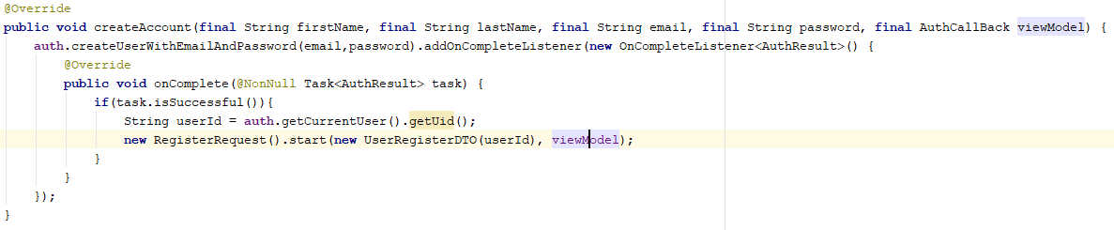

The viewModel is passed to RegisterRequest class in order to retrieve the response object once server responses.

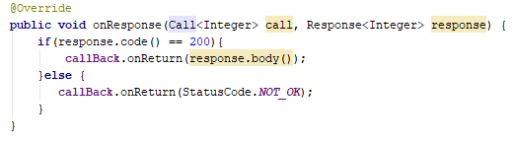

When logging in to the application the data being checked is email and password. If these are matching the task is successful and the status code is set to OK.

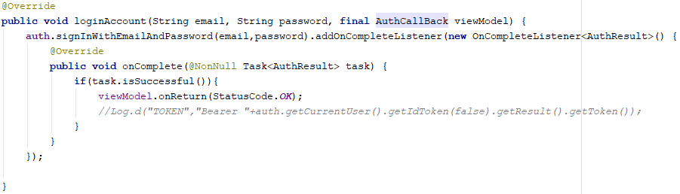In loginActivity class the initViewModel() method is observing for a change in the status code. If the status code is true new intent is started.

